**Worksheet-3.3**

**Student Name**: Sahil Kaundal **UID:** 21BCS8197

**Branch**: CSE(LEET) **Section/Group:** 807/B

**Semester**: 4th **Date of Performance**: 11/05/2022

**Subject Name**: CN Lab **Subject Code:** 20CSP-257

1. **Aim/Overview of the practical:**

Create network to implement TCP/IP protocol.

1. **Task to be done/ Which logistics used:**

Create network to implement TCP/IP protocol.

TCP/IP stands for Transmission Control Protocol/Internet Protocol and is a suite of communication protocols used to interconnect network devices on the internet. TCP/IP is also used as a communications protocol in a private computer network (an [intranet](https://www.techtarget.com/whatis/definition/intranet) or extranet).

The entire IP suite -- a set of rules and procedures -- is commonly referred to as TCP/IP. [TCP](https://www.techtarget.com/searchnetworking/definition/TCP) and [IP](https://www.techtarget.com/searchunifiedcommunications/definition/Internet-Protocol) are the two main protocols, though others are included in the suite*.*The TCP/IP protocol suite functions as an abstraction layer between internet applications and the routing and switching fabric.

1. **Apparatus/Simulator used** **(For applied/experimental sciences/materials-based labs):**

Cisco Packet Tracer

Generic Router

Switch

End Devices.

1. **Steps:**

**Step 1:** Create a system using routers, switches and different end devices.

**Step 2:** Connect all the end- devices with switch.

**Step 3:** Connect router with each other.

**Step 4:** Assign IPs to all devices.

**Step 5:** Drop Packet and start simulation.

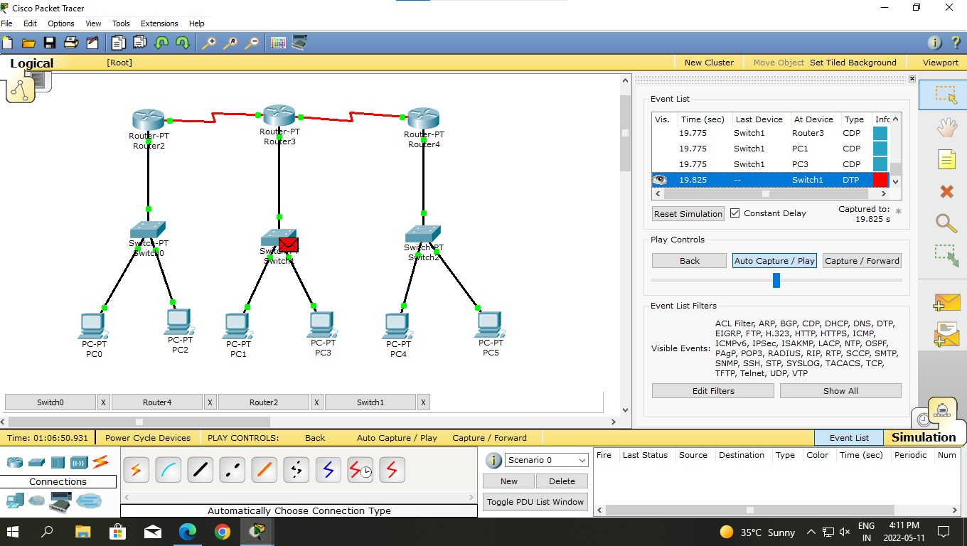

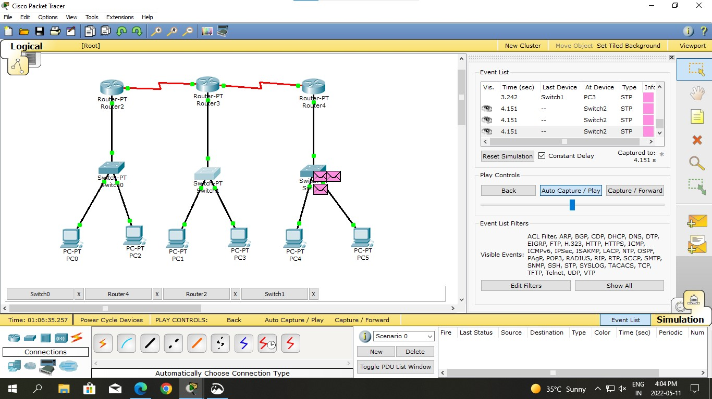

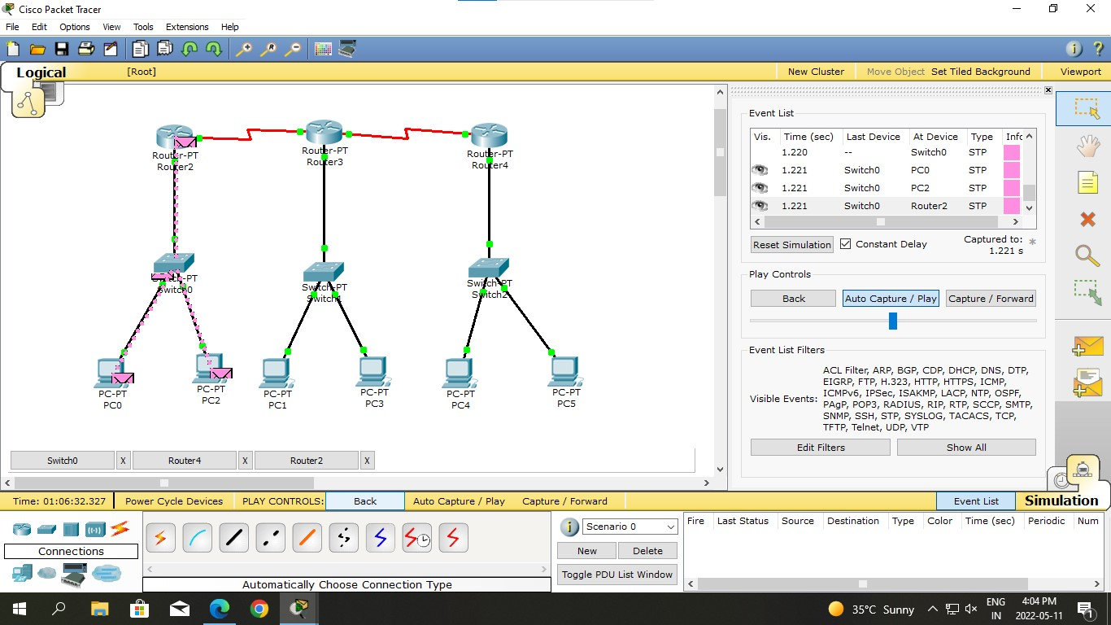

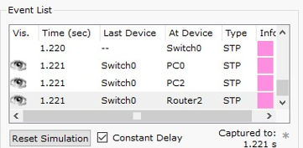

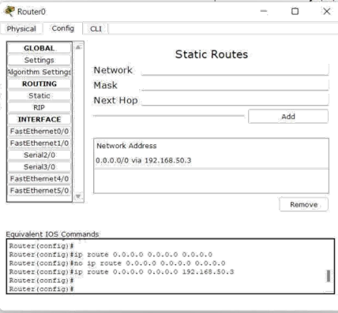

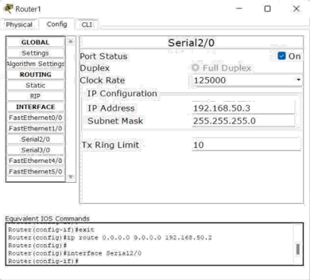

**Result: -**

I have successfully completed this experiment.

**Learning outcomes (What I have learnt):**

1. Created network to implement TCP/IP protocol.

**Evaluation Grid (To be created as per the SOP and Assessment guidelines by the faculty):**

|  |  |  |  |
| --- | --- | --- | --- |
| Sr. No. | Parameters | Marks Obtained | Maximum Marks |
| 1. |  |  |  |
| 2. |  |  |  |
| 3. |  |  |  |
|  |  |  |  |